Project RCG

Game Design Document

Caerwyn Bartley | Alex Smits | Sebastian Biala-Learmonth

Project Overview 2

Game Description: 2

Market Analysis 2

Target Market: 2

Design Pillars 2

Personas 3

Targeted Platform 4

Competitor Analysis 4

Mechanics 5

2D platformer Movement 5

Randomisation 6

Dialogue 7

Menus 7

Visual Input Feedback 8

Scene Change 9

# Project Overview

## Game Description:

Randomised controls game is a 2D platformer where the player’s controls progressively randomise to the point where none of them serve the same purpose anymore and the player needs to keep relearning the control scheme of the game to keep proceeding. The game is intended to evoke feelings of frustration and exasperation by repeatedly mixing up the controls and disorienting the player in this way, with added buttons that cause negative effects to occur, further contributing to this feeling.

By showcasing players being able to clear the game even with extremely unintuitive ways of movement and the game being stacked against you, randomised control game demonstrates that players will continue experimenting to figure out and endure what the game throws at you. This supports the lack of need for extremely fundamental, redundant tutorials in games and proves the hypothesis that players will be able to figure out how to play regardless.

# Market Analysis

## Target Market:

People who enjoy short gaming experiences with a tolerance or liking for frustrating “rage” games. This is especially true for needing the players to also be able to adapt to the new control schemes, as while they might be able to figure them out easily enough to prove the hypothesis, being able to play with these controls is another issue altogether. Because of the design decisions made, another potential target audience is that of gaming content creators, be it people who stream or make videos, as such a type of game is often associated with that audience.

With this in mind, a design consideration that will need to be considered is that of humour to both take the edge off dying, and to provide some comedy for anyone who may be watching someone play the game. Ensuring that the game feels properly frustrating by giving the player glimpses of hope before tearing them away will also make for a more engaging experience compared to just making it feel bad and boring to play.

# Design Pillars

**Frustrating Gameplay –** The core mechanic of RCG will be utilised in a variety of situations to present the player with that will present great difficulty for the player to overcome, with loss of progression being an especially threatening outcome.

**Satisfying Accomplishments -** RCG must be satisfying to maintain engagement and provide an adequate reward for overcoming the frustrating aspects of gameplay.

**Fun to Watch -** RCG is focused on the idea of a game designed for streamers and requires additional attention placed in feedback to effectively convey information to an audience as well as the player.

## Personas

**Player**

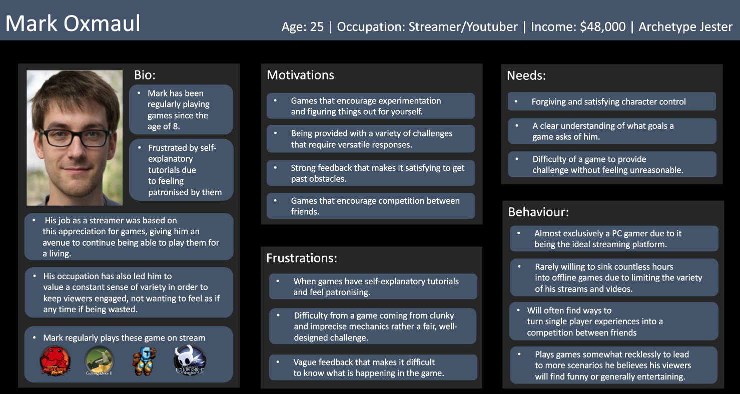

**Viewer**

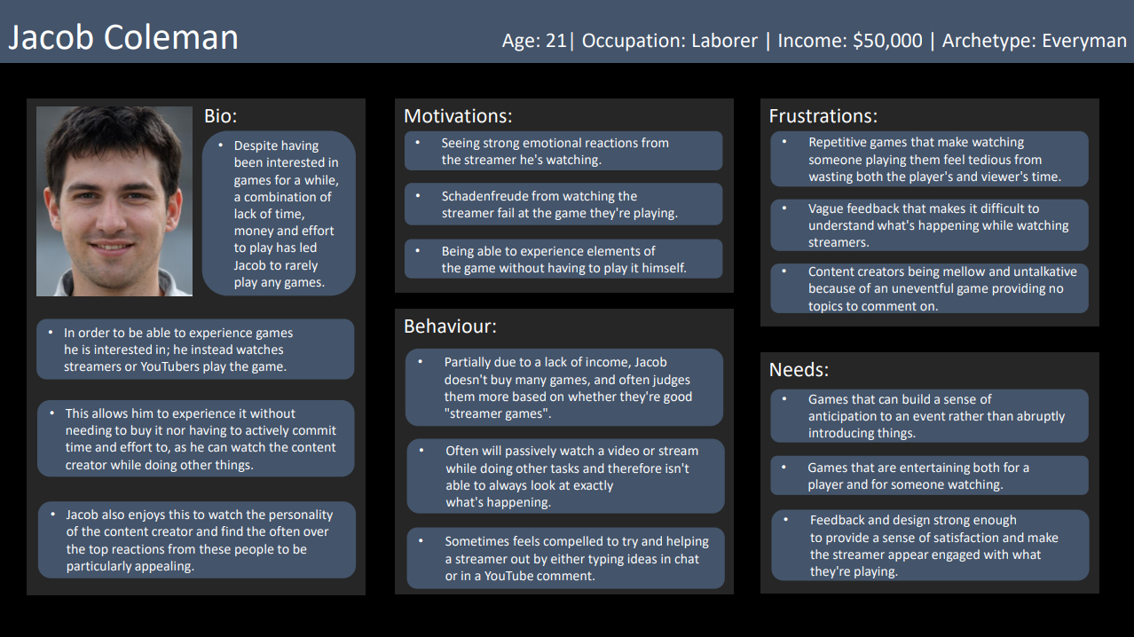

## Targeted Platform

**PC (Windows, Mac, Linux)**

RCG requires a large array of input methods for the core game mechanic to function as designed. Therefore, the launch of the game will be restricted to just the PC platform. For future consideration, the game could run on consoles provided that an eternal keyboard be attached. However, this would require players to make an external purchase in some instances and would not be feasible.

Alternatively, the core gameplay could be redesigned for use on a controller with significantly less input options. However, once again, this would subtract from the games overall vision and present a subpar experience to console owners. For these reasons, mechanically the game can only function on the PC platform.

An additional factor for pushing the PC platform above others relates to the ease and accessibility of streaming. As consoles continue to advance and become more synonymous with PCs, this is increasingly becoming a moot point.

## Competitor Analysis

**Jump King**

<https://store.steampowered.com/app/1061090/Jump_King/>

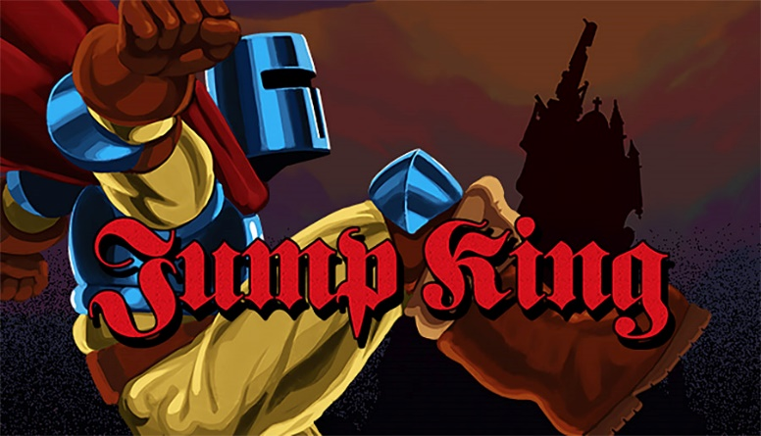

Summary

A pixel perfect 2D platformer tasking the player with scaling a large tower where the wrong move can cause them to lose progress and fall.

Genre

Platformer, Adventure, Indie

Platform

PlayStation 4, Nintendo Switch, Android, Microsoft Windows, Xbox One

Relevance

Jump King has a similar aesthetic to RCG in the sense that it is a 2D pixel art platformer with unintuitive controls. Both games feature the potential to lose progress by falling down.

**Getting Over It**

<https://store.steampowered.com/app/240720/Getting_Over_It_with_Bennett_Foddy/>

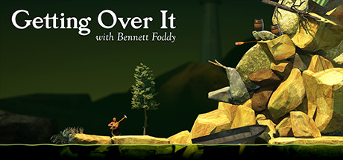

Summary

A game with unconventional controls that have you climb up a mountain using a hammer, where one wrong move can have you lose a lot of progress while the game taunts you all the way along.

Genre

Platformer, Adventure, Indie

Platform

Android, iOS, Microsoft Windows, Classic Mac OS, Linux

Relevance

Getting Over It is a game seemingly designed specifically to frustrate people and be played by content creators, with everything being built around the ideas of panic and anticipation to imminent failure. This approach towards game design to build everything around this central idea of crushing moments of failure will provide inspiration for the design of RCG.

# Mechanics

## 2D platformer Movement

Description: Standard Character Controller similar to other contemporary games in the genre.

Details:

* Player can move side to side, jump and crouch
* Player can move while crouching
* Jump buffering and coyote time are utilised to make the jumping feel better
* Controls will be moved around at certain points due to the randomisation mechanic.



Related Mechanics & Systems

* Randomisation
* Visual Feedback

## Randomisation

Description

When walking over certain triggers, the designated controls of the player will be randomised

Details

* The controls that are randomised are pre-determined
* The randomisation mechanic can apply to anywhere from one to all controls depending on the level
* Controls are set back to default once the scene changes.



Related Mechanics & Systems

* 2D Platformer Movement
* Visual input feedback

## Dialogue

Description

When walking past certain triggers, a dialogue box will appear

Details

* Dialogue will mainly be used to inform the player of which controls were changed
* The dialogue box is made to look like a speech bubble and will follow the player as they move
* The dialogue box appearing will not stop the character from moving
* The box will disappear after a few seconds have passed.



Related Mechanics & Systems

* Player movement
* Randomisation

## Menus

Description A standard navigation tool for the player to select levels and manoeuvre the game’s content.

Details

* Consist of a main menu & in-game menu
* Main menu allows players access to a level select and the credits
* In game menu allows player to back out of level or game

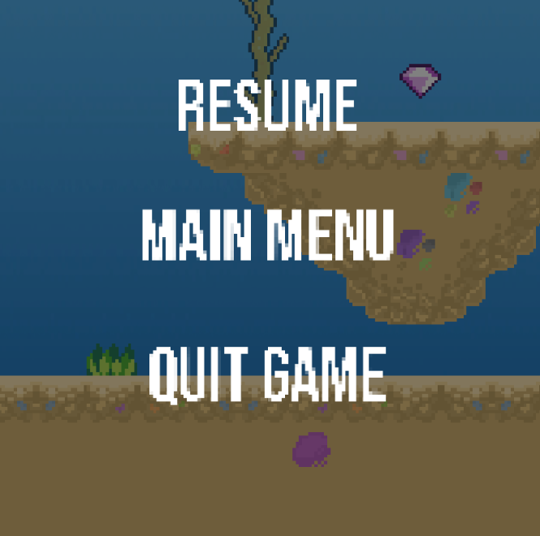

Related Mechanics & Systems

* Scene Change / Levels

## Visual Input Feedback

Description

UI elements to visually show what keys the player is pressing and whether or not they do anything.

Details

* There are 2 separate components to the feedback system, a UI keyboard layout and bubbles that appear on-screen when you press the corresponding key
* Only one key is registered at a time, so pressing every key at on the same frame will only generate a single bubble.
* When a key is pressed, the corresponding key on the UI keyboard layout will become opaque until the player stops holding down the key.
* If the key the player is holding down is a key that has a function, the UI key will light up green. If the button currently has no purpose, the key will light up red.



Related Mechanics & Systems

* Randomisation
* Player Movement

## Scene Change / Levels

Description

When collecting a gem at the end of the level, an animation will play, and the scene will change

Details

* When transitioning scenes, an animation will play both to exit the current scene and to appear in the next
* The new scene begins with a cutscene where it shows the player the end point of the level and then pans over to the player
* While the cutscene plays, the character will be unable to move



Related Mechanics & Systems

* Player movement